

Dynamics 365 – Warehouse Management

Revision 1
Revision History

Date | Revision | Description | Signature / Date
03/10/2022 | 1 | Initial draft of user manual: Dynamics 365 – Warehouse Management | Prepared | Waseem Abbas
 |  |  | Verified
 |  |  | Approved
 |  |  | Prepared
 |  |  | Verified
 |  |  | Approved
 |  |  | Prepared

Table of Contents
1 About User Manual 5
1.1 Dashboard Overview 5
2 Warehouse Management 5
2.1 Warehouse Creation 6
2.2 Delete Warehouse 7
3 Location 7
3.1 Location Creation 7
3.2 Delete Location 8
4 Location Wizard 8
4.1 Creation of Location Wizard 9

List of Figures
Figure 1. Dashboard Overview 5
Figure 2 Warehouse 6
Figure 3 Create Warehouse 6
Figure 4 Delete Warehouse 7
Figure 5 Location 7
Figure 6 Location Creation 8
Figure 7 Delete Location 8
Figure 8 Location Wizard 9
Figure 9 Creation of Location Wizard 9

About User Manual
This document describes the step-by-step guide of manually creation of a purchase order (PO) of a product or a list of sub-products (items). These purchase orders (POs) are, typically, created by a purchase user (employee) in a legal entity (legal organization). The purchase user creates and forwards the purchase order (PO) to a vendor, who has been chosen (selected) for that product through purchase requisition bidding process.
The step-by-step guide of a purchase order (PO) creation and then creation of invoice will be explained.

Dashboard Overview
After logging in, the you will see the main dashboard, which includes the grid of individual Workspaces (in the middle), which are represented in the Figure 1.
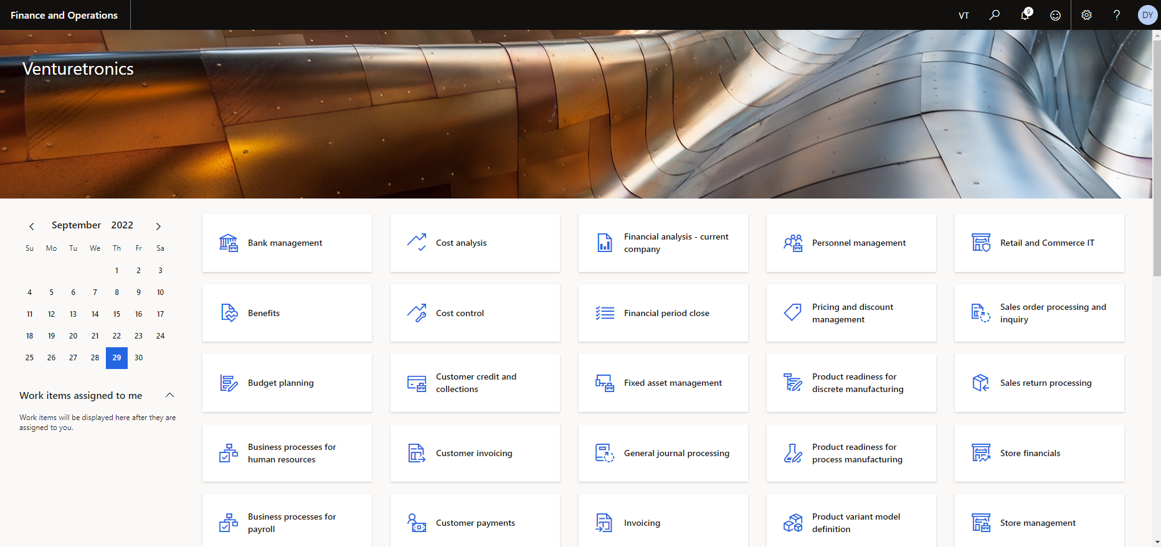
Figure 1. Dashboard Overview

Warehouse Management
As a first step to open the warehouse management user need to go to module and click on ‘Warehouse Management’ which have been shown in Figure 2.
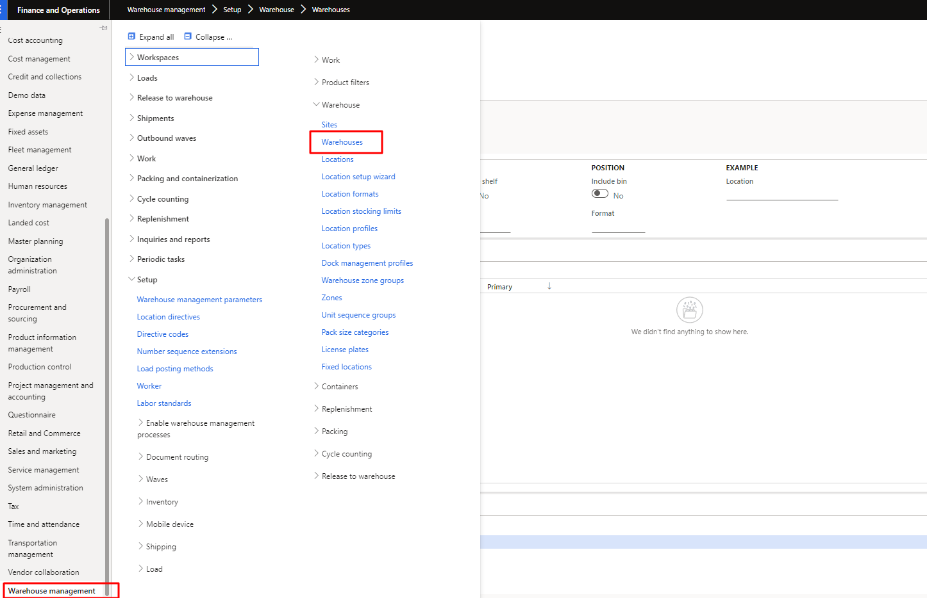
Figure 2 Warehouse

Warehouse Creation
As step 1, the purchase user can access the new warehouse creation form by clicking on New button in tap bar. As the user click on new need to fill the fields as per requirements and then click on Save to save the new warehouse. The process is also shown in the Figure 3.
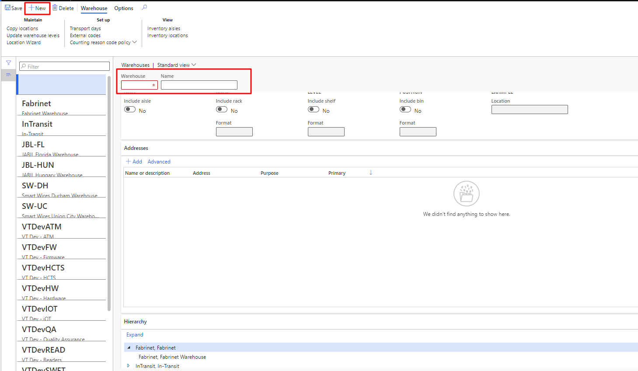
Figure 3 Create Warehouse

Delete Warehouse
In step 2, the purchase user can access the delete warehouse form the list by clicking on Delete button in tap bar. As the user click on delete then popup will show up, there user need to click on ‘Yes’ to delete the selected item. The process is also shown in the Figure 4.
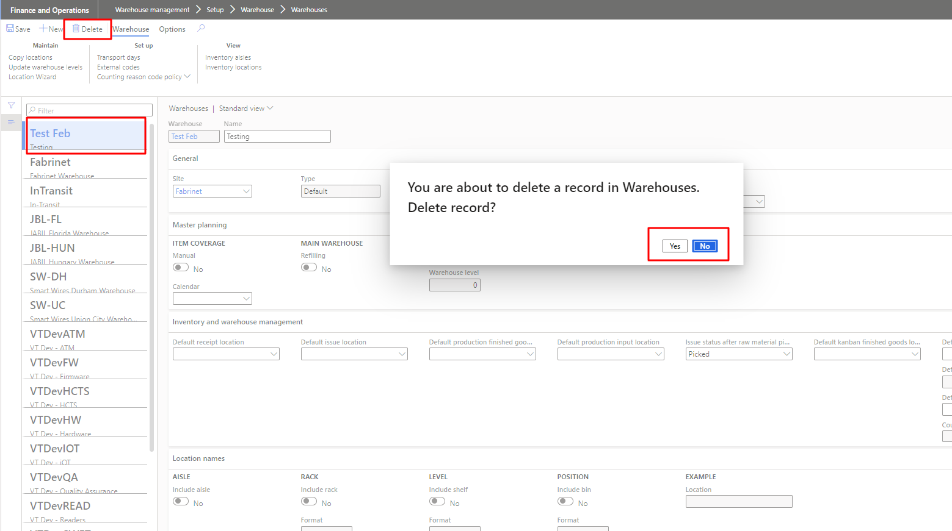
Figure 4 Delete Warehouse

Location
As a first step to open the warehouse management user need to go to module and click on Warehouse Management then click on location. which have been shown in Figure 5.
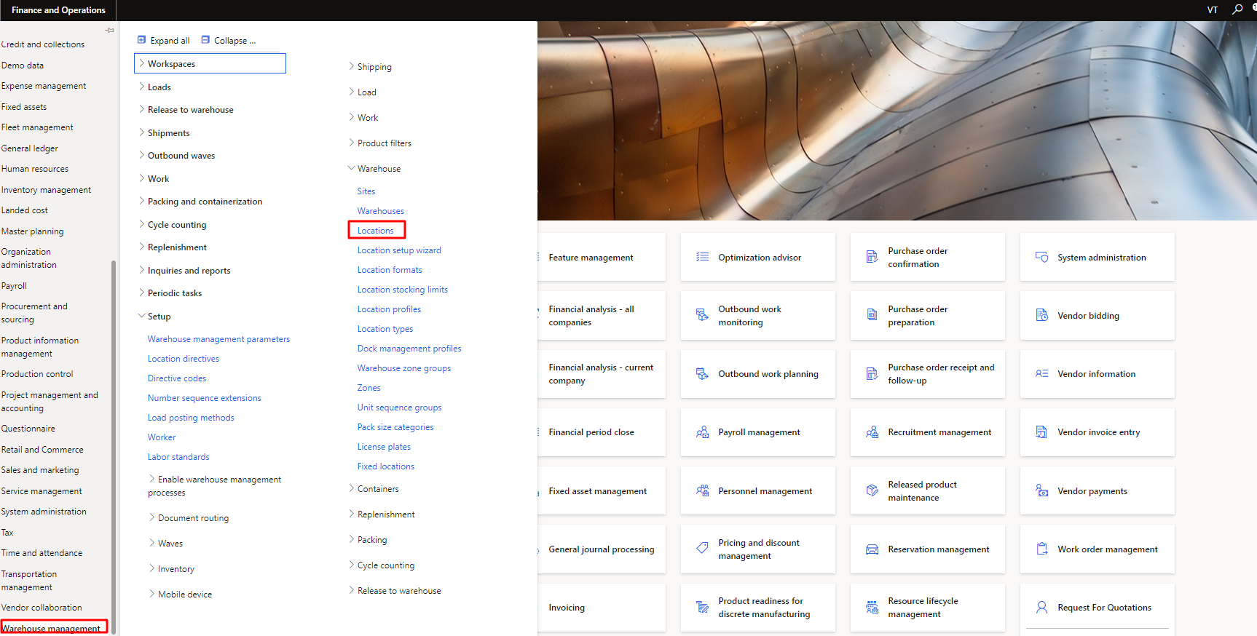
Figure 5 Location

Location Creation
As step 1, the purchase user can access the new location creation form by clicking on New button in tap bar. As the user click on new need to fill the fields as per requirements and then click on Save to save the new warehouse. The process is also shown in the Figure 6.
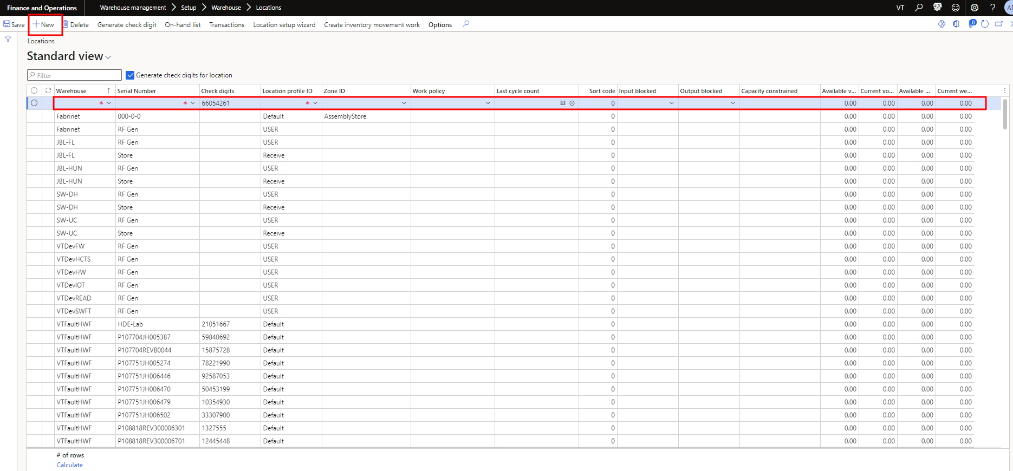
Figure 6 Location Creation

Delete Location
In step 2, the purchase user can access the delete location form the list by clicking on Delete button in tap bar. As the user click on delete then popup will show up, there user need to click on Yes to delete the selected item. The process is also shown in the Figure 7.
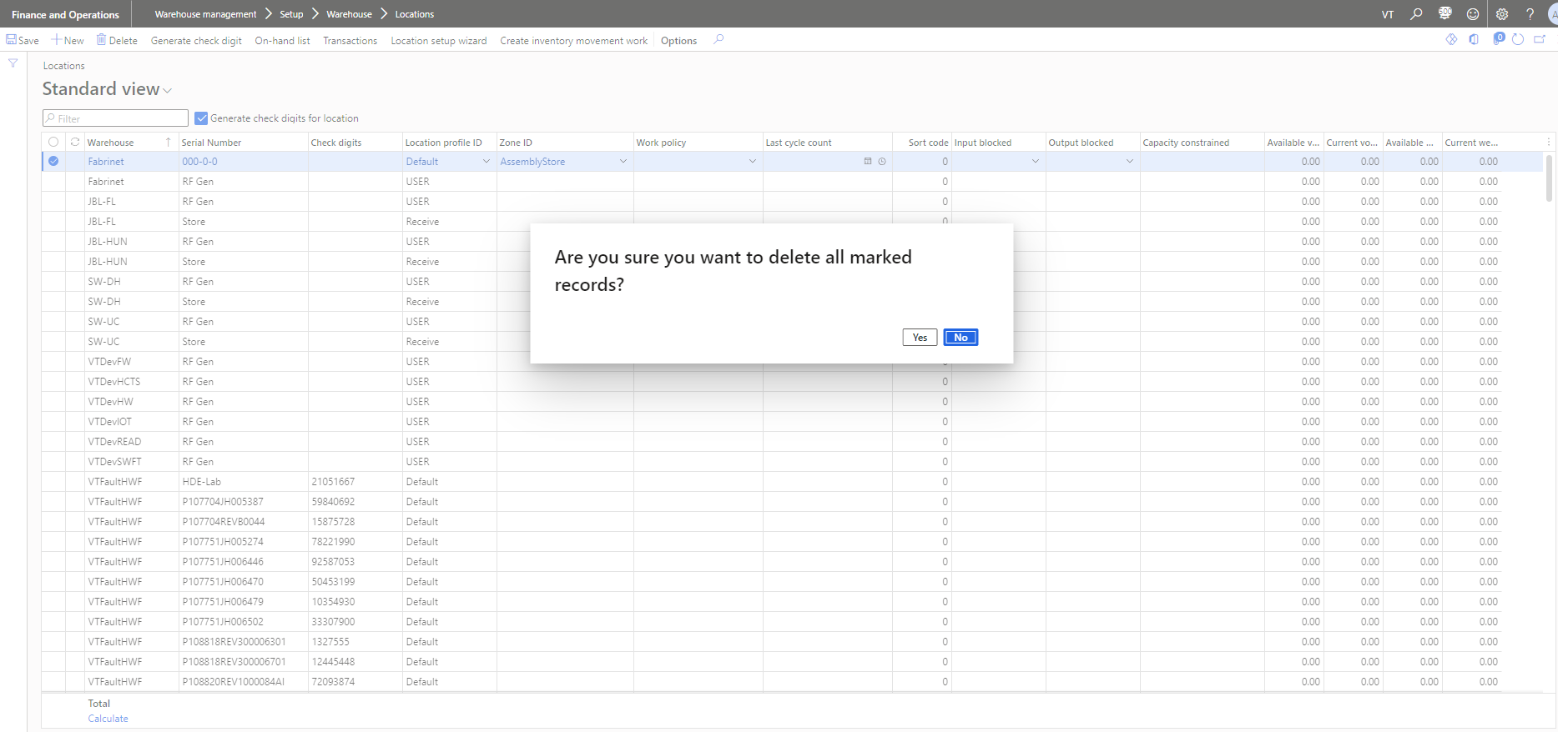
Figure 7 Delete Location

Location Wizard
As a first step to open the warehouse management user need to go to module and click on Warehouse Management then click on location Setup Wizard. which have been shown in Figure 8.
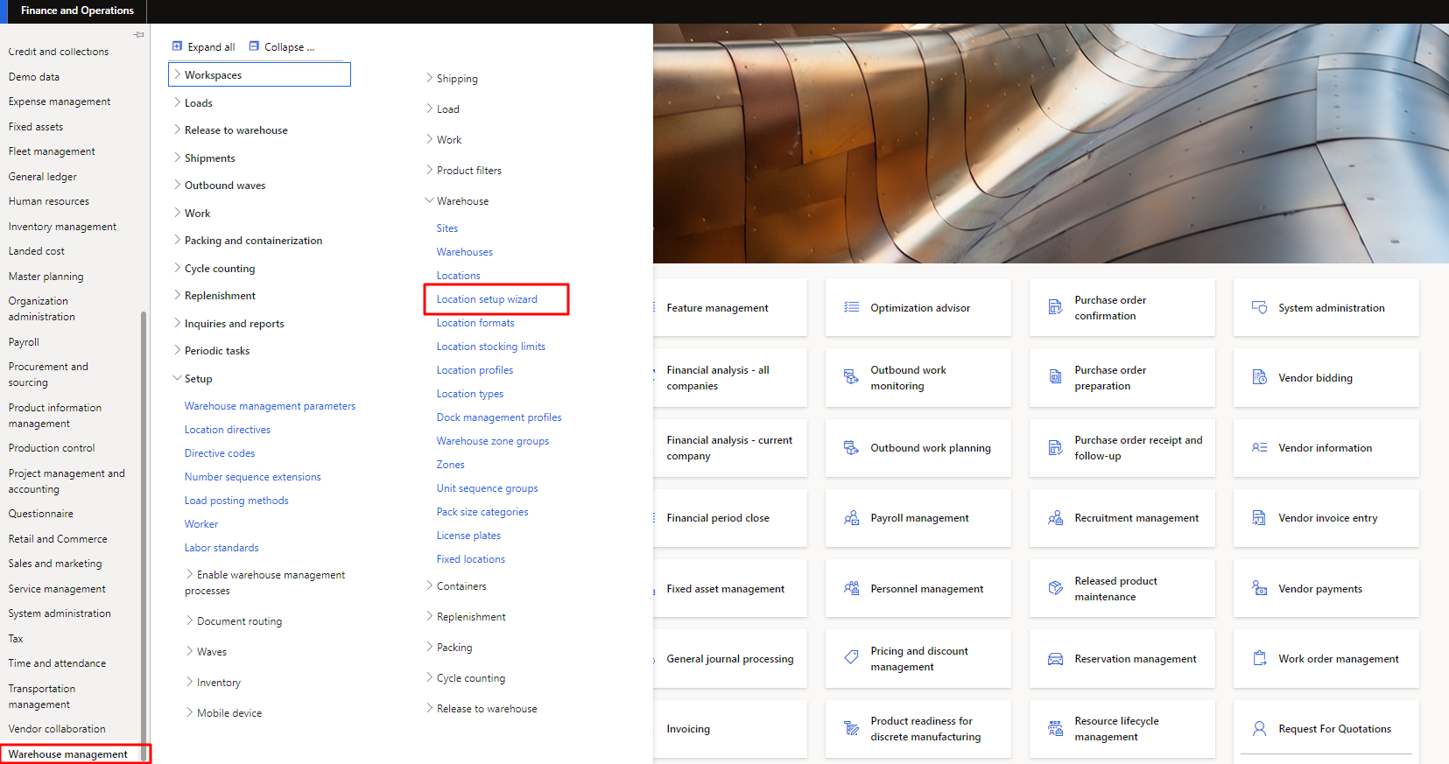
Figure 8 Location Wizard

Creation of Location Wizard
As step 1, the purchase user can access the new location creation wizard form by clicking on Location wizard setup from warehouse management. As the user click on new need to fill the fields as per requirements and then click on create to Save the new locations. The process is also shown in the Figure 9. 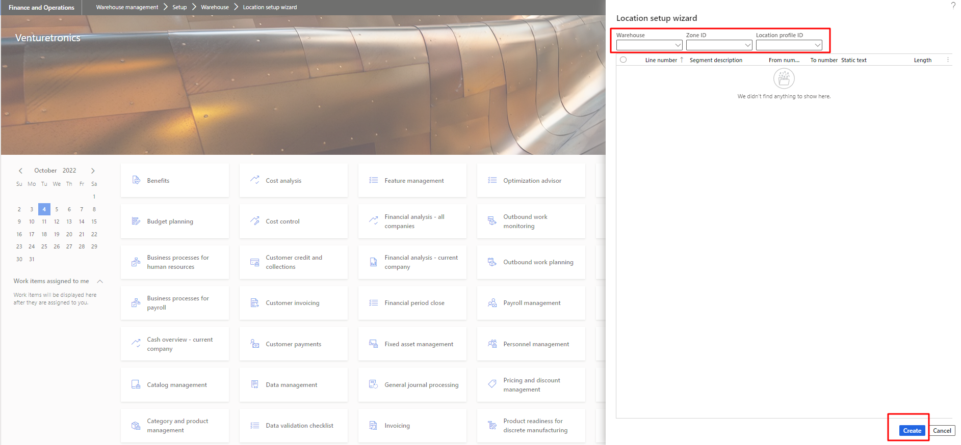
Figure 9 Creation of Location Wizard

